JavaScript Assignment

JavaScript-- Javascript is a dynamic computer programming language. It is lightweight and most
commonly used as a part of web pages, whose implementations allow client-side script
to interact with the user and make dynamic pages.

Ques 1. Prompt for amount, interest rate and no. of years and calculate simple interest.?

Ans 1. Prompt-- The prompt() method pops up the dialog box which is used to take the input from
the user at client side server.
>>Take the input from user of amount, interest rate and no. of years.
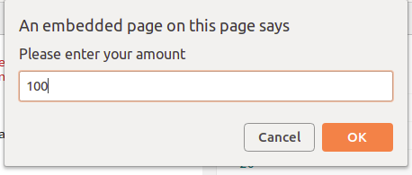

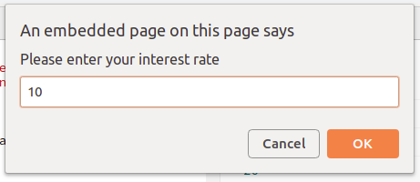

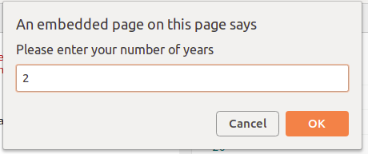

>> Now calculate the simple interest.
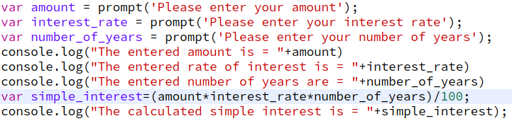
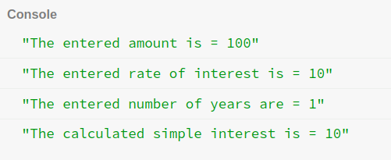
Output--

Ques 2. is palindrome string?

Ans 2. Palndrome-- A word or a sequence that reads the same from backward as forward.
Eg-- MADAM, RACECAR.

Program to check palindrome---
function isPalindrome(string)
{

return string = string.split('').reverse().join('') ? true : false

}

console.log(isPalindrome("madam"))

Output-- true

Function Used-->
split()-- splits a string into an array of substrings i.e., splits each element.
reverse()--Reverse the order of elements in the array.
join()--Joins array elements using provided separator and returns string.

Ques 3. Area of circle ?

Ans 3. Program to find area of circle-->
var radius=prompt('Enter the radius of the circle')
var pi=3.14
var area_of_circle=pi*radius*radius
console.log(area_of_circle)

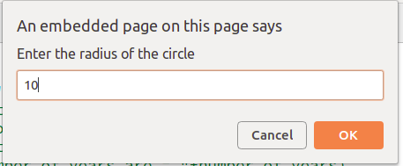

Output-- 314

Ques 4. Copy information of one object to another and log it to console.?

Ans 4. >>We will define one object and then copy the data of first object to the second object.
Program--->

var object1 = {
id: 1,
name: "Suraj Pandey",
Department: "Development",
Designation: "Trainee"
};

var object2 = Object.assign({}, object1);
console.log(object2);
Output-->
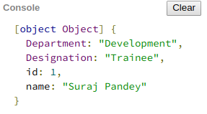

Ques 5. create a list of objects of Employee with info as follow :
  - Name, age, salary ,DOB
  - filter all employees with salary greater than 5000
  - group employee on the basis of their age
  - fetch employees with salary less than 1000 and age greater than 20. Then give them an increment 5 times their salary.
Ans 5. 1. Name, age, salary ,DOB

var employee = [];
var Emp1 = {name: "Suraj", age: 21, salary: 1500, DOB:"05/08/1996"};
employee.push(Emp1);
var Emp2 = {name: "Suraj1", age: 21, salary: 15000, DOB:"07/08/1996"};
employee.push(Emp2);
var Emp3 = {name: "Suraj2", age: 21, salary: 15000, DOB:"09/08/1996"};
employee.push(Emp3);
var Emp4 = {name: "Suraj3", age: 21, salary: 500, DOB:"10/08/1996"};
employee.push(Emp4);
var Emp5 = {name: "Suraj4", age: 20, salary: 1500, DOB:"11/08/1996"};
employee.push(Emp5);

2. filter all employees with salary greater than 5000

function filterEmp()
{
for(var i=0;i<3;i++)
{
if(employee[i].salary>5000){
console.log(employee[i].name)
}
}
}
filterEmp()
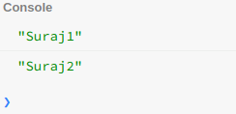

3. group employee on the basis of their age.

var groupBy = function(xs, key) {
return xs.reduce(function(rv, x) {
(rv[x[key]] = rv[x[key]] || []).push(x);
return rv;
}, {});
};
var age = groupBy(employee,'age');
console.log("GroupedBy list = ");console.log(age);

OR

function GroupBy(emp) {
var Arr = [],
employee= {},
i, j=emp.length, current;
for (i = 0; i < j; i++)
{
current = emp[i];
if (!(current.age in employee))
{
employee[current.age] = {employee: [], Age: current.age};
Arr.push(employee[current.age]);
//console.log(Arr)
}
employee[current.age].employee.push(current.name);
employee[current.age].employee.push(current.age);
employee[current.age].employee.push(current.salary);
employee[current.age].employee.push(current.DOB);
}
return Arr;
}
console.log(GroupBy(employee));
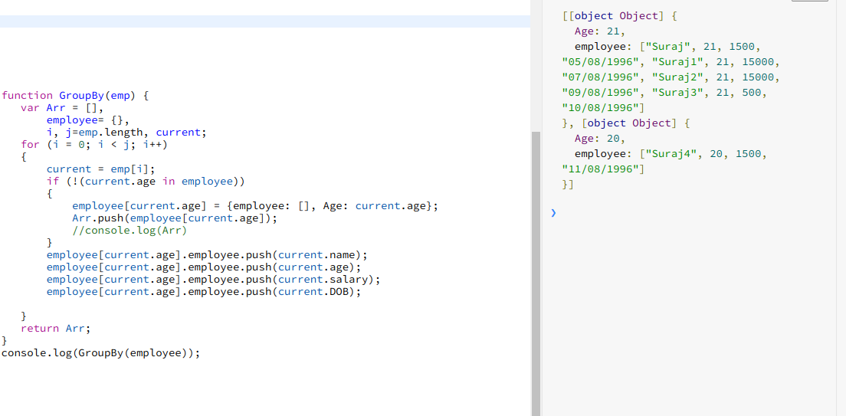
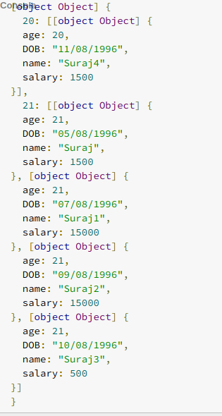

4 . fetch employees with salary less than 1000 and age greater than 20. Then give them an increment 5 times their salary.

function filterEmp()
{
for(var i=0;i<5;i++)
{
if(employee[i].salary<1000 && employee[i].age>20)
{
employee[i].salary=employee[i].salary*5
console.log(employee[i].name)
console.log(employee[i].salary)
}

}

}

filterEmp()

